ASSIGNMENT 2 – CO2
Functions and Object-Oriented Concepts in C++
Bloom's Level K5 – Evaluate | Total Marks: 50 | Individual Assignment
Item | Details
Name | __Hemalatha.C__
Register Number | __192524475__
Submission Date | 31/10/2026
GitHub Repository | https://github.com/Hemalatha-1806/DSA0102-C-
Compiler | g++ 13.3.0 (Ubuntu), Linux x86-64
Compile command | g++ -std=c++17 -Wall -Wextra file.cpp -o file
Timing runs | The same command with -O0 or -O2 added (Q6 and Q7)

How this report is organised
For every question I give the program, the prediction I made before running it, the real output, and the explanation. Predictions are shown before the outputs. The main programs were compiled with -Wall -Wextra and gave no warning; the only warning and errors in this report are the ones shown on purpose in Q2 and Q3. Timings are from my own machine, so the exact milliseconds will be different on another computer; the comparison between versions is what matters.

Summary of results (README note for each task)
Task | Folder | Result
Q1 | Q1 | Predicted output 1 12 13 / 1 100 / 16 13 6 was correct. Only call by reference and call by pointer change the stored fee (45000 → 40500). Design chosen: return the new fee. Complete-the-code output matches the expected output.
Q2 | Q2 | Returning int& lets +2 moderation change the array element directly. Returning a reference to a local gives warning -Wreturn-local-addr and crashes with a segmentation fault when used. A vector buffer moved after push_back, so an old reference becomes invalid.
Q3 | Q3 | Original code gives "call of overloaded charge(double) is ambiguous". Redesign with int / double / Parcel overloads and defaults on one function per type. All 6 predicted selections were correct; charge(2) selects the grams version.
Q4 | Q4 | SavingsAccount keeps the last 10 transactions in a private array (members defined inside and outside the class). 12 transactions were made and only the last 10 are shown. A circular buffer prints the same statement.
Q5 | Q5 | Token prediction 101 103 104 4 was correct. BusTicket output matches expected (Seat 1, 2, 3, Waiting, Issued: 3). The static counter keeps its value across function calls.
Q6 | Q6 | Friend functions give 205 false. All six correctness tests pass. At -O2 the inline version is about 13% faster than a forced non-inline call; at -O0 inline makes no difference.
Q7 | Q7 | Redesigned the Q4 shifting array as a circular buffer. Recording time became independent of capacity; 5.6× to 1913× faster at -O0 depending on capacity, identical statement, no extra memory (padding absorbed the new int).

Q1 – Call by Value, by Reference and by Pointer (6 Marks)
Folder: Q1 Files: predict.cpp, three_ways.cpp, complete.cpp

1.1 Predict the Output
My prediction (written before running)
1 12 13
1 100
16 13 6

How I got it: change(a, b, &c) – a is passed by value, so only a copy becomes 11 and the real a stays 1. b is a reference, so the real b becomes 12. c is passed as an address and *c += 10 changes the real c to 13. In bigger(a, c) = 100 the values are 1 and 13, so the function returns a reference to c and the assignment writes 100 into c. Finally the three show() calls print 16, 13 and 6, each followed by a space.
Program :
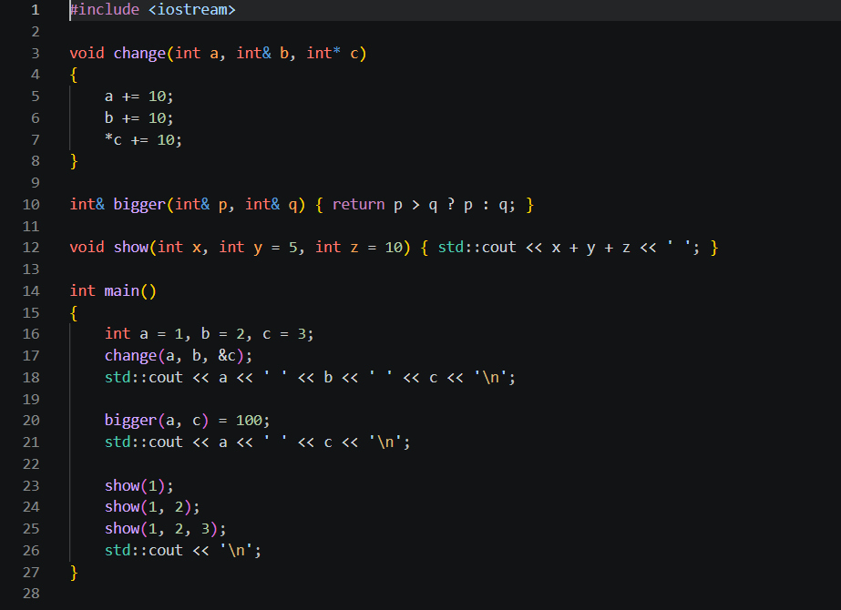

Actual output
1 12 13
1 100
16 13 6

Difference between prediction and output: none. The last line ends with a space after the 6 because show() prints ' ' after every number, and the '\n' comes only afterwards from main().
Which variables changed in each call
Call | a | b | c | Reason
change(a, b, &c) | 1 (no change) | 2 → 12 | 3 → 13 | a: by value (copy). b: reference (alias). c: pointer, changed through *c.
bigger(a, c) = 100 | 1 | 12 | 13 → 100 | Returns int& to the larger one (c), so the assignment changes c itself.

Default arguments used by each call to show()
Call | x, y, z used | Defaults used | Calculation
show(1) | 1, 5, 10 | y = 5 and z = 10 | 1 + 5 + 10 = 16
show(1, 2) | 1, 2, 10 | z = 10 only | 1 + 2 + 10 = 13
show(1, 2, 3) | 1, 2, 3 | none | 1 + 2 + 3 = 6

1.2 Hostel Fee Concession – three versions
The fee is 45,000 and the concession is 10% (merit). Before running I predicted: by value → stored fee stays 45000, by reference → 40500, by pointer → 40500.
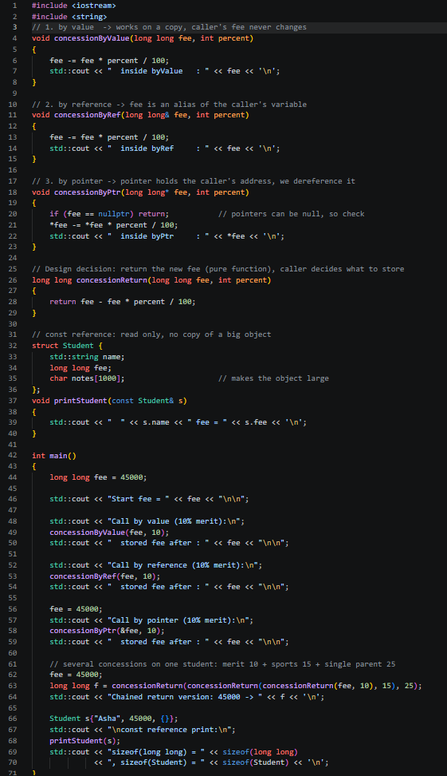

Observed output
Start fee = 45000

Call by value (10% merit):
inside byValue : 40500
stored fee after : 45000

Call by reference (10% merit):
inside byRef : 40500
stored fee after : 40500

Call by pointer (10% merit):
inside byPtr : 40500
stored fee after : 40500

Chained return version: 45000 -> 25819

const reference print:
Asha fee = 45000
sizeof(long long) = 8, sizeof(Student) = 1040

The prediction was correct. Note that the by-value function also prints 40500 inside, which is exactly why the bug looked like "it works" – the print inside the function shows the local copy, not the stored fee.

1.3 Inquiry
Where each version stores its parameter
Version | Where the parameter lives | Caller's fee changed?
By value | A new local variable (8 bytes) in the function's stack frame, holding a copy of the value. | No
By reference | No new fee variable. The name fee is just another name (alias) for the caller's variable. | Yes
By pointer | A new local pointer variable (8 bytes on 64-bit) holding the address of the caller's variable. The fee itself stays in the caller. | Yes, through *fee

Only reference and pointer let the function reach the caller's original memory. In call by value the function works on its own copy, and that copy is destroyed when the function returns, so the change is lost.
When to use a const reference: when the function only needs to read an object and the object is big or expensive to copy (a Student with strings and arrays, a vector, a std::string). const Student& avoids the copy and the compiler stops the function from modifying it. For small types like int or long long plain by value is just as cheap, so a const reference gives no benefit there.

1.4 Design Decision – in place or return the new fee?
My choice: return the new fee. The signature is [[nodiscard]] long long applyConcession(long long fee, int percent) and the caller writes fee = applyConcession(fee, 10);.
- Several concessions can be chained: applyConcession(applyConcession(applyConcession(fee, 10), 15), 25) gives 25819 for 45000. No temporary variables are needed.
- The function has no side effects, so the office can preview the fee before saving it, and it is easy to test.
- The data flow is visible at the call site. The original bug happened because nothing in the call showed that the result was being thrown away. With [[nodiscard]] the compiler warns if the caller forgets to store it.
One more thing I noticed: because integer division truncates, the order of concessions changes the answer. 10% → 15% → 25% gives 25819, but 25% → 15% → 10% gives 25820 (I checked both by hand and by running). So the office must fix one order in the rules. The in-place reference version would be better only when updating one big record again and again and the copy cost matters, which is not the case for a single long long.

1.5 Complete the Code
TODO 1 is filled with the same formula, but on the reference parameter so that the caller's variable is changed. Nothing else in the program was changed.
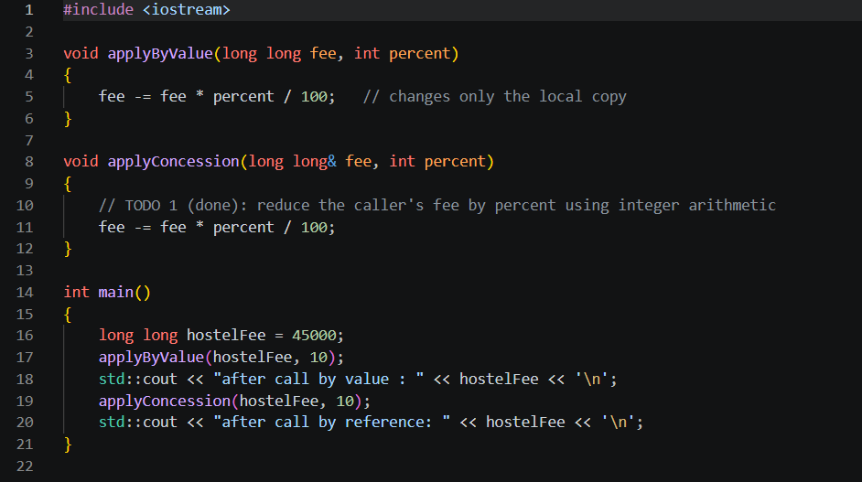

Output (matches the expected output)
after call by value : 45000
after call by reference: 40500

Why call by value leaves 45000: applyByValue receives its own copy of hostelFee. The line fee -= fee * percent / 100 reduces that copy to 40500, and the copy is destroyed when the function ends. hostelFee in main was never touched.

1.6 Alternative Concept and Complexity Analysis
Instead of changing the fee through a reference, the function can return the new fee (this is the version from 1.4):
long long applyConcession(long long fee, int percent)
{
return fee - fee * percent / 100;
}

// caller
hostelFee = applyConcession(hostelFee, 10);

Time is O(1) for all versions: one multiplication, one division and one subtraction. What differs is the amount of data copied per call (measured with sizeof in my program: long long = 8 bytes, my test Student with a 1000-character notes array = 1040 bytes):
Passing style | long long (8 B) | Student (1040 B) | Space complexity
By value | 8 bytes copied | 1040 bytes copied every call | O(1) for long long, O(s) for an object of size s
By reference | nothing copied (address only) | nothing copied (address only) | O(1)
By const reference | nothing copied | nothing copied, and read-only | O(1)
Return new fee | 8 bytes returned | not suitable for big objects | O(1) for long long

So for a single fee the cost of copying is negligible and returning the value is the safest design. For a large Student object, a const reference is the right way to read it and a non-const reference the right way to modify it.

Q2 – Return by Reference and Its Dangers (4 Marks)
Folder: Q2 Files: marks.cpp, bad_call.cpp, warning.txt

2.1 Working functions
highest() returns int& to the element with the largest mark. Because it is a reference to the array element itself, highest(marks, 5) += 2; applies the +2 moderation directly to the array, with the call on the left side of the assignment operator. (In Q1, bigger(a, c) = 100 used plain = in the same way.)
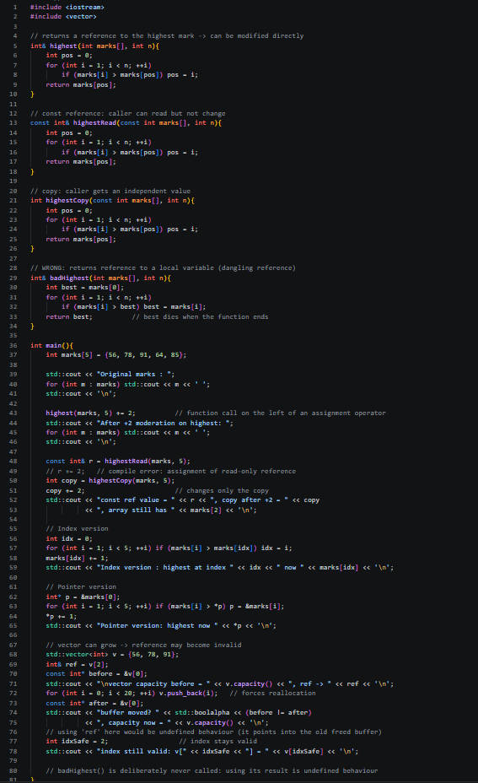
Output
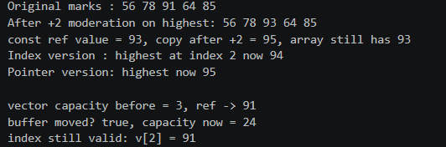
The marks 56 78 91 64 85 became 56 78 93 64 85 – only the highest mark (91) was changed. The "capacity now = 24" value depends on the standard library implementation; the important part is that the buffer moved.

2.2 Returning a reference to a local variable
The function badHighest() stores the best mark in a local variable best and returns a reference to it. Compiling with g++ -std=c++17 -Wall -Wextra gives this warning:
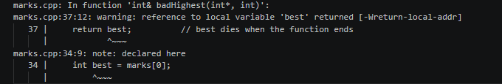
The reason is that best lives on the function's stack frame and is destroyed when the function returns. The caller receives a reference to memory that is no longer valid – a dangling reference. Reading or writing through it is undefined behaviour: the program may print garbage, may seem to work, or may crash. To see this I wrote bad_call.cpp which uses the returned reference:
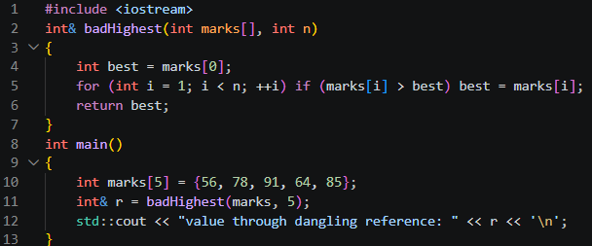

Result on my machine (both -O0 and -O2)
Segmentation fault (exit code 139)

GCC does not even give the address of the dead local variable here; it returns a null reference, so the program crashes. On another compiler or version the result can differ, and that is exactly the problem with undefined behaviour.

2.3 Reference vs const reference vs copy
Return type | What the caller gets | Can the caller change the array? | Notes
int& | The element itself (alias) | Yes, | Can be used on the left of =. Dangerous if the object dies.
const int& | The element itself, read only | No (compile error on r += 2) | No copy, no accidental change. Still dangling if the array is destroyed.
int | An independent copy | No (only the copy changes) | Always safe. Copy is cheap for int. Used in the program: copy became 95 but array stayed 93.

2.4 Changed Condition – the register is a std::vector that can grow
A std::vector keeps its elements in one block of memory. When push_back needs more room than the current capacity, the vector allocates a bigger block, copies (moves) the elements and frees the old block. A reference, pointer or iterator taken earlier still points into the old block, so it is dangling. In my test the reference ref = v[2] was taken when capacity was 3; after 20 push_backs the buffer address changed (buffer moved? true) so using ref would be undefined behaviour. I did not use it after that point on purpose.
Safe ways: take the reference only after all insertions are finished, use reserve() beforehand so the vector never reallocates, or keep an index and look up v[i] each time.

2.5 Alternative Concept and Complexity Analysis
Returning an index or a pointer instead of a reference:
int highestIndex(const int marks[], int n) // returns -1 if n == 0
{
int pos = 0;
for (int i = 1; i < n; ++i) if (marks[i] > marks[pos]) pos = i;
return n > 0 ? pos : -1;
}
int* highestPtr(int marks[], int n) // returns nullptr if n == 0
{
int* best = marks;
for (int i = 1; i < n; ++i) if (marks[i] > *best) best = &marks[i];
return n > 0 ? best : nullptr;
}

// calling code
marks[highestIndex(marks, 5)] += 2; // index version
*highestPtr(marks, 5) += 2; // pointer version
highest(marks, 5) += 2; // reference version

All three scan the array once, so the time is O(n) and the extra space is O(1) (one int or one pointer). The difference is safety:
Version | Empty array (n = 0) | After the vector grows | Verdict
int& (reference) | Cannot report "not found"; a reference must refer to something | Dangling → undefined behaviour | Cleanest syntax, least safe
int* (pointer) | Can return nullptr (caller must check) | Dangling, same as reference | Can signal failure, but same lifetime risk
int (index) | Can return -1 | Still valid, as long as no elements are erased or inserted before it | Safest when the container can grow

So for a fixed array the reference version is fine and very convenient. Once the register becomes a growing vector, I would return the index.

Q3 – Default Arguments and Function Overloading (6 Marks)
Folder: Q3 Files: ambiguous.cpp, courier.cpp, long_call.cpp, alt_struct.cpp

3.1 The compiler error
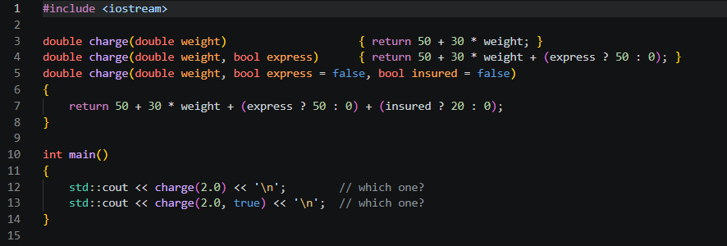
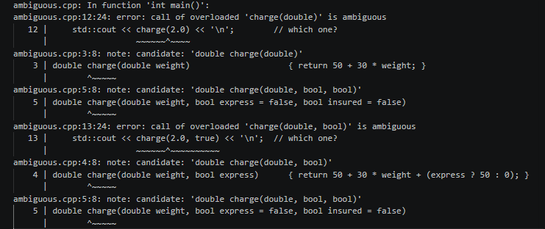For charge(2.0) both charge(double) and charge(double, bool = false, bool = false) are viable and both are an exact match on the one argument given. The defaulted parameters do not make the second one a worse match, so the compiler cannot choose and reports an ambiguous call. In the same way charge(2.0, true) matches both charge(double, bool) and the three-parameter version. The root cause is that the same call can be written in several ways because the default arguments overlap with the other overloads.

3.2 Redesign
Rule I followed: only one function per kind of input carries the default arguments, and the default arguments are written only in the declaration. The three kinds of input are grams (int), kilograms (double) and a Parcel object.
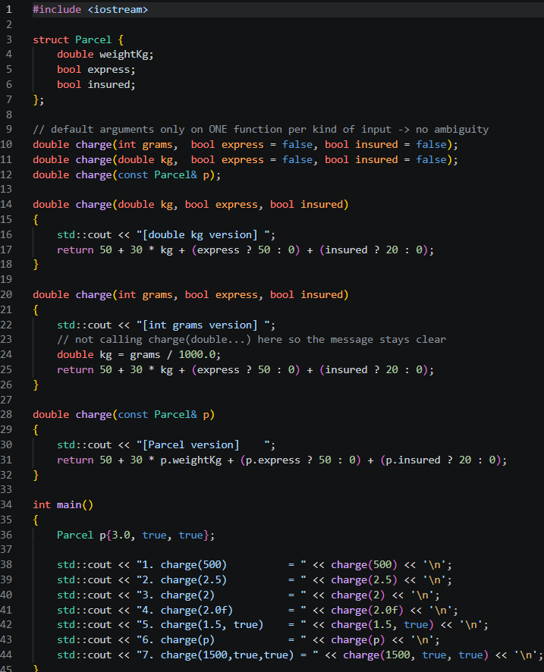
My predictions (before execution) and what was observed
No. | Call | Predicted function | Reason
1 | charge(500) | int grams | 500 is an int → exact match
2 | charge(2.5) | double kg | 2.5 is a double → exact match
3 | charge(2) | int grams | 2 is an int. It is 2 grams, not 2 kg (50.06)!
4 | charge(2.0f) | double kg | float → double is a promotion; float → int is a conversion. Promotion wins.
5 | charge(1.5, true) | double kg, express | double exact; true matches bool
6 | charge(p) | Parcel | Parcel exact match

Observed output
1. charge(500) = [int grams version] 65
2. charge(2.5) = [double kg version] 125
3. charge(2) = [int grams version] 50.06
4. charge(2.0f) = [double kg version] 110
5. charge(1.5, true) = [double kg version] 145
6. charge(p) = [Parcel version] 210
7. charge(1500,true,true) = [int grams version] 165

All predictions matched. Call 3 is the trap: charge(2) silently chooses the grams version, so a user who means 2 kg gets a charge of 50.06. This is a weakness of overloading on unit by type. It can be avoided by giving the functions different names, or by using small wrapper types such as Grams and Kilograms. Another trap: charge(2L) (a long) does not compile because long → int and long → double are both conversions of equal rank:
The output order of the labels and the "[... version]" tags is correct only from C++17 onwards, where the left operand of << is evaluated first, so I compile with -std=c++17.

3.3 Inquiry – how the compiler chooses
The compiler first collects all functions with that name, then keeps those that can accept the arguments (number of arguments, and a conversion exists). Among these it ranks each argument conversion from best to worst:
- Exact match – same type (also adding const, array-to-pointer, reference binding).
- Promotion – float → double, char/short/bool → int.
- Standard conversion – int → double, double → int, long → int, etc.
- User-defined conversion – through a converting constructor or conversion operator.
The function that is better on at least one argument and not worse on any other wins. If no function is clearly best, the call is ambiguous. The return type is never used in this decision.
Why default arguments must be given from the right: in a call the arguments are matched to parameters by position from the left, and you cannot skip a middle argument. If a middle parameter had a default but a later one did not, the default could never be used. So void f(int a = 1, int b); is a compile error, while void f(int a, int b = 2, int c = 3); is legal.

3.4 Alternative Concept and Complexity Analysis
Instead of overloads with default arguments, one struct with optional fields, or one function template:
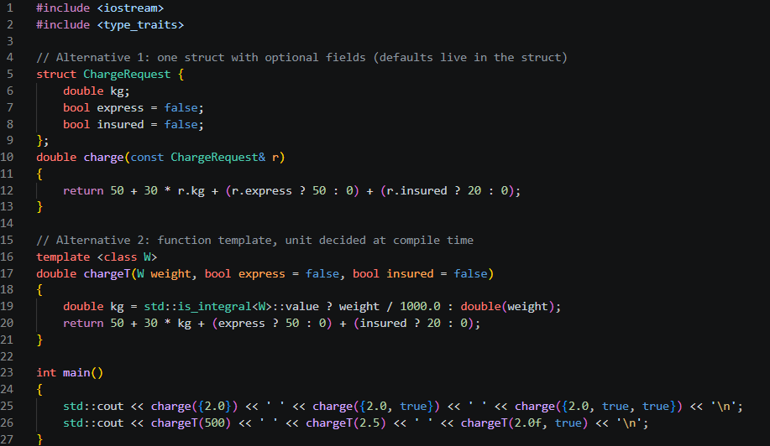
Output
110 160 180
65 125 160

 | Overloads + defaults | Struct with optional fields | Function template
Time | Overload resolution at compile time, no run-time cost. Function itself O(1). | Same, O(1) | Same, O(1) (resolved at compile time)
Space copied per call | A few bytes (a double/int and two bools, in registers) | Passed by const reference: nothing copied (16 bytes if by value) | Same as overloads; one extra copy of the function body per type (code size, not run time)
Adding a new option (e.g. fragile) | Add another defaulted parameter to every overload; calls like charge(2.0, false, true, false) become unreadable | Add one field with a default; no existing call changes | Add the parameter to the template; same readability problem as overloads
Ambiguity risk | High (as seen) | None | Medium (type deduced, e.g. charge(2) means grams)

For three optional things the overload design is fine and short to call. If more options are expected, the struct approach grows best.

Q4 – Specifying a Class with an Array Inside It (6 Marks)
Folder: Q4 Files: account_shift.cpp, account_circular.cpp

4.1 Class specification
Private data: account number, balance, an array of 10 Transaction records and a count. Public functions: deposit(), withdraw() and miniStatement(). getBalance() and deposit() are defined inside the class (implicitly inline). withdraw(), miniStatement() and the private helper record() are defined outside with SavingsAccount:: (scope resolution operator). Older transactions are removed by shifting the array left.
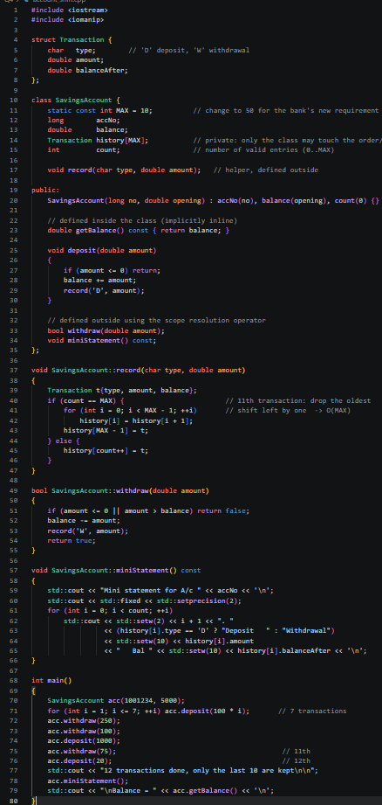
Output (12 transactions made, only the last 10 are shown)
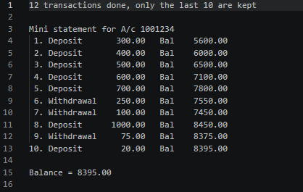
The first two deposits (100 and 200) were dropped when the 11th and 12th transactions arrived, so the statement starts at the 300 deposit. The balance is the real balance, because balance is updated separately from the history.

4.2 Inquiry
Why the array must be private. The class depends on two rules: count is never more than 10, and the array is in order from oldest to newest. If the array and count were public, any code could write count = 15 and then miniStatement() would read past the end of the array (undefined behaviour), or change an old transaction without changing the balance. Keeping it private means only the member functions can change it, so the rules always hold. It also lets me change the inside later (for example to a circular buffer, see Q7) without touching any code that uses the class.
What happens at the 11th transaction.
Method | What happens | Cost per new transaction | Space
Shift the array | Every element moves one place left (9 copies of a 24-byte record for k = 10), the oldest falls out, the new one goes in the last slot. | O(k) | Fixed array of k records
Circular index | The new transaction overwrites the slot of the oldest one, and the start index moves by one (with wrap-around). Nothing is copied. | O(1) | Fixed array of k records + one int (start)

Reading the statement costs O(k) in both designs, because all k entries are printed.

4.3 Design Decision – last 50 transactions
The circular-index design changes least. In both designs the size is only the constant MAX (change 10 to 50), because every loop and the array use MAX and nothing else is hard-coded. But the cost behind that change is different. With shifting, one transaction now copies 49 records instead of 9, so recording becomes about five times more work (my measurement in Q7: 21.6 ms → 92.2 ms for 1,000,000 transactions at -O0). With the circular index the cost per transaction stays the same, and the code of deposit(), withdraw() and miniStatement() does not change at all. Memory for each account grows from 264 to 1224 bytes in both designs; that is a cost of the requirement, not of the design.

4.4 Alternative Concept and Complexity Analysis
Circular buffer version of the class (full program in account_circular.cpp); it prints exactly the same statement as the shifting version, which I confirmed with diff:
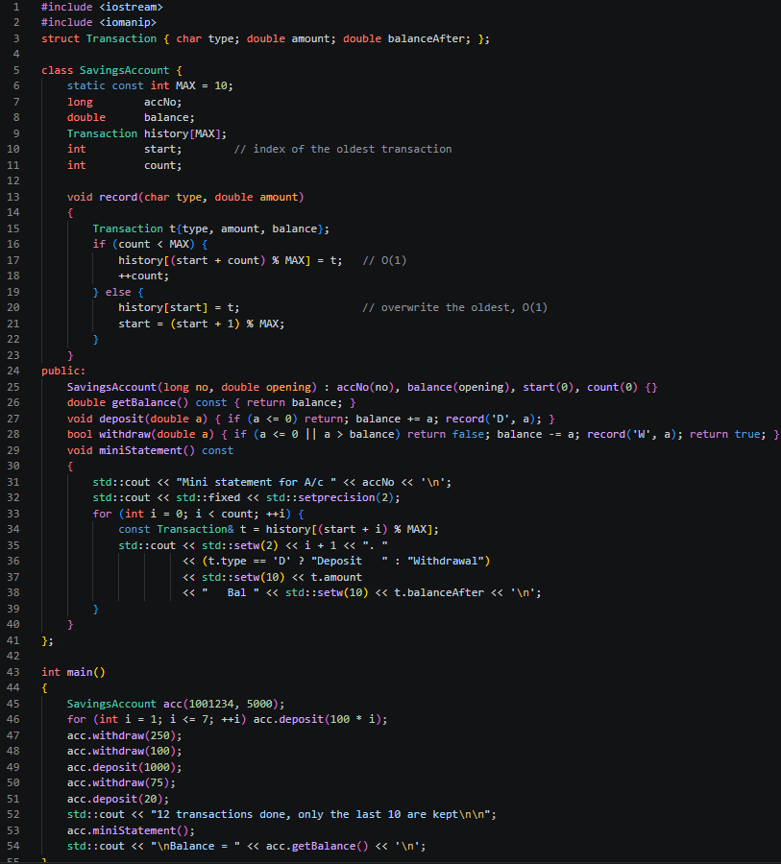

With std::deque the code is simply h.push_back(t); if (h.size() > MAX) h.pop_front();.
Design | Add a transaction | Space | Comments
Shift fixed array | O(k) | O(k) fixed | Simplest code and the array is always in order. Time grows with k.
Circular buffer | O(1) | O(k) fixed + one int | Fastest. Index arithmetic (start + i) % MAX is needed when reading.
std::deque | O(1) amortised | O(k) + block bookkeeping | No manual index code and size can change, but it allocates memory on the heap and is slower than the buffer in my test.

Measured timings for all three are in Q7.

Q5 – Static Members and Arrays of Objects (7 Marks)
Folder: Q5 Files: token.cpp, busticket.cpp, busticket_function.cpp, busticket_big.cpp, ticketoffice.cpp

5.1 Predict the Output
My prediction (written before running)
101 103 104 4

Reasoning: next starts at 100. The array of 3 creates tokens with ids 101, 102, 103, then extra gets 104. So counter[0].get() = 101, counter[2].get() = 103, extra.get() = 104, and issued() = 104 − 100 = 4.
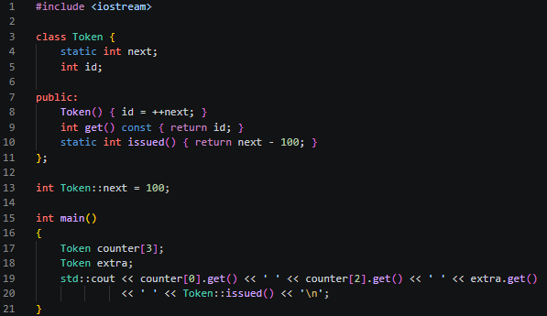
Actual output
101 103 104 4

No difference. The static counter starts at 100 because of the line int Token::next = 100; outside the class. A static data member has static storage duration and it is initialised once, before main() starts, not by any constructor. The constructor ran 4 times (3 for the array elements plus 1 for extra), and each run did ++next on the same shared variable.

5.2 From the principle to a class design
Principle: data that belongs to the whole class should exist only once. For the bus tickets that gives:
- Static data members: issued (seats given so far) and CAPACITY (seats in the bus). They describe the bus, not one ticket, so there must be one copy only.
- Non-static members: seat and name – every ticket has its own.
- Static member function: count() – the transport office can call BusTicket::count() without any ticket object.
Where a static data member is defined. Inside the class it is only declared. It must be defined exactly once outside the class in one source file: int BusTicket::issued = 0;. Without it the program compiles but fails at link time with "undefined reference". (static const int CAPACITY = 3; is an exception: an integral constant with an initialiser can be used directly, because it is only used as a value here.)
Why a static member function cannot use this or a non-static member. this is the address of the object a member function was called on. A static function is called on the class (BusTicket::count()) and there may be no object at all, so there is no this and no seat or name that it could mean. It can only use static members. Writing static int getSeat() { return seat; } gives the error "invalid use of member in static member function".
How the array is created. BusTicket has only a constructor that needs a name, and it is explicit, so there is no default constructor. Therefore BusTicket trip[4]; would not compile; every element must be initialised: BusTicket trip[4] = {BusTicket("Asha"), BusTicket("Bala"), ...};. The constructors run in order of the index, so the seats are given in the order of the list.
What happens to the count in a loop or function. The counter belongs to the class, not to any object, so destroying objects does not reduce it. Tickets created inside a function or loop increase issued each time, and the value is still there after the function returns (shown in 5.4).

5.3 Complete the Code
TODO 1: if issued < CAPACITY, increase issued and take it as the seat number, otherwise seat stays 0 (waiting list). TODO 2: return issued.
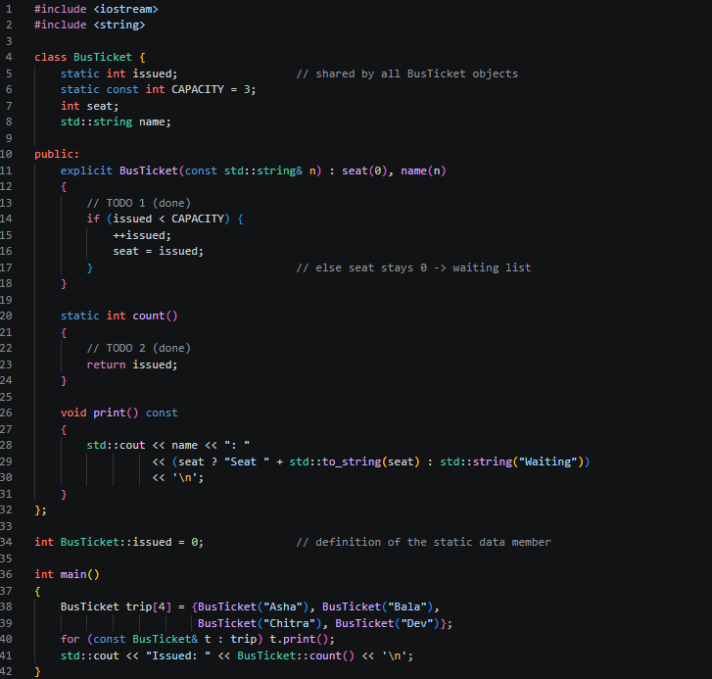
Output (matches the expected output)
Asha: Seat 1
Bala: Seat 2
Chitra: Seat 3
Dev: Waiting
Issued: 3

5.4 Test Your Design
Array larger than the capacity (6 tickets, 3 seats):
Asha: Seat 1
Bala: Seat 2
Chitra: Seat 3
Dev: Waiting
Eswar: Waiting
Fathima: Waiting
Issued: 3

Tickets created inside a function that is called three times (two tickets each time, in busticket_function.cpp):
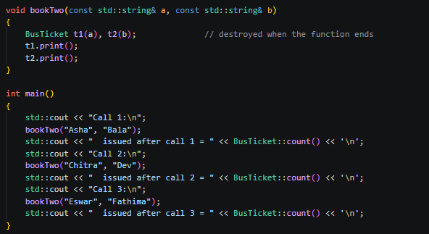
Call 1:
Asha: Seat 1
Bala: Seat 2
issued after call 1 = 2
Call 2:
Chitra: Seat 3
Dev: Waiting
issued after call 2 = 3
Call 3:
Eswar: Waiting
Fathima: Waiting
issued after call 3 = 3

The local tickets are destroyed at the end of every call, but issued stays at 2, then 3, then 3. Seat 3 was given in the second call, and from then on everybody goes to the waiting list. One consequence of this design: if a passenger cancels and the ticket object is destroyed, the seat is not given back, because nothing decrements the static counter. A real system would need a destructor or a cancel function for that.

5.5 Alternative Concept and Complexity Analysis
Seat counter in a separate TicketOffice object passed to every ticket (the global variable version would look the same, with the counter outside any class):
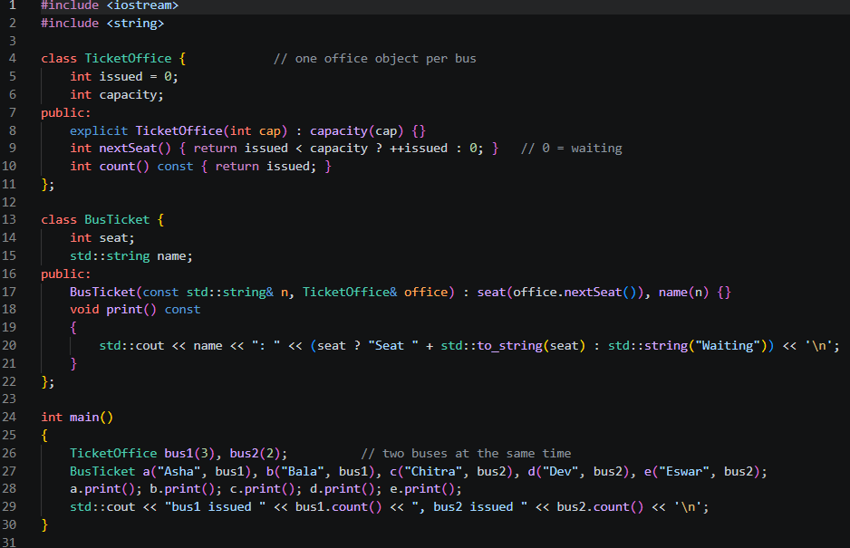
Asha: Seat 1
Bala: Seat 2
Chitra: Seat 1
Dev: Seat 2
Eswar: Waiting
bus1 issued 2, bus2 issued 2

 | Static data member | Global variable | TicketOffice object
Time per ticket | O(1) | O(1) | O(1)
Space | One counter (4 bytes) | One counter | One counter per office (one int + capacity)
Encapsulation | Good: private, only BusTicket can change it | Poor: any code can change it, name clashes possible | Good: only the office's functions change it
Two buses at once | No. One counter for the whole class, so both buses would share seat numbers | No, same problem | Yes. One TicketOffice per bus, as in the output above
Extra work | None | None | Every ticket constructor needs the office as argument

For one college bus the static member is the simplest and safest. If the college adds a second bus, the TicketOffice design is better.

Q6 – Friend Functions and Inline Functions (8 Marks)
Folder: Q6 Files: time_friend.cpp, time_tests.cpp, bench.cpp

6.1 Design of the comparison
Why a friend function. minutesBetween(a, b) treats both times equally. If it were a member function, one time would be the special "this" object and the other a parameter, which is awkward for a symmetric operation. A normal function needs access to the private h and m of both objects; declaring it as a friend inside the class gives exactly that access to exactly these functions, without adding public getters.
Friend vs member function.
 | Member function | Friend function
How it is called | a.minutesTo(b) – on an object, with the dot | minutesBetween(a, b) – ordinary call, no object before it
this pointer | Has one | Has none
Is it in the class scope? | Yes, it is a member | No. It is only declared in the class (friend) and defined outside
Access to private data | Yes, of the object and of other objects of the same class | Yes, of every object it is given, because the class granted friendship

What inline asks the compiler to do. inline is a request to put the body of the function directly at the place of the call instead of making a real call (saving the work of passing arguments, jumping and returning). It is only a request; the compiler may refuse it, and at -O0 GCC does not inline at all. With -O2 GCC inlines small functions on its own, even without the keyword. The keyword also has a second, guaranteed meaning: the same definition may appear in several files (needed for functions defined in a header). Functions defined inside a class are automatically inline.
What would be lost if h and m were public. Encapsulation. Any code could set h = 45; m = 99; and create a time that does not exist, and there would be no single place to check it. The class could also never change its internal form (for example to store minutes since midnight) without breaking all the code that uses h and m directly.

6.2 Complete the Code
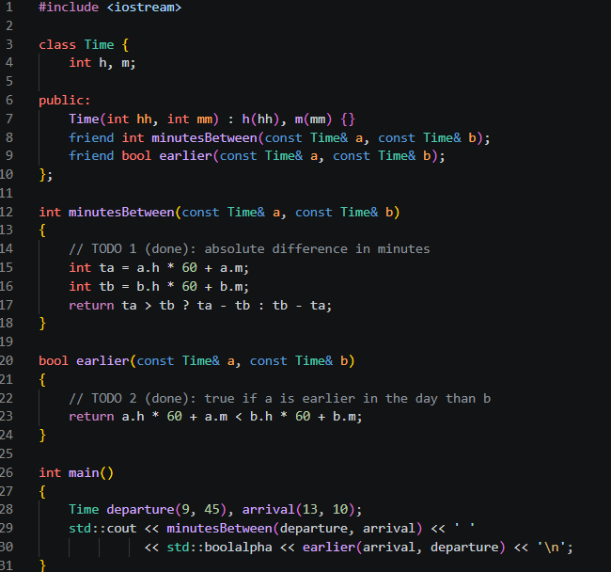
Output (matches the expected output)
205 false

6.3 Correctness Check
Hand calculation: 09:45 = 9 × 60 + 45 = 585 min, 13:10 = 790 min, difference 205. 11:50 = 710 and 12:20 = 740, difference 30. 00:00 = 0 and 23:59 = 1439, difference 1439.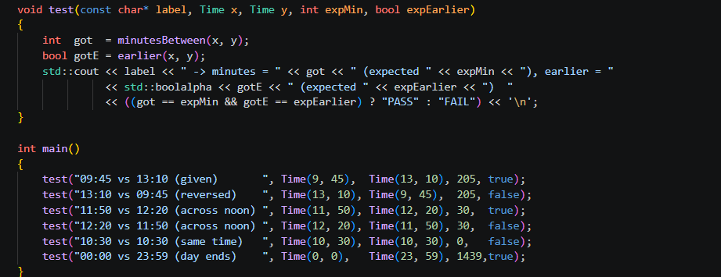
09:45 vs 13:10 (given) -> minutes = 205 (expected 205), earlier = true (expected true) PASS
13:10 vs 09:45 (reversed) -> minutes = 205 (expected 205), earlier = false (expected false) PASS
11:50 vs 12:20 (across noon) -> minutes = 30 (expected 30), earlier = true (expected true) PASS
12:20 vs 11:50 (across noon) -> minutes = 30 (expected 30), earlier = false (expected false) PASS
10:30 vs 10:30 (same time) -> minutes = 0 (expected 0), earlier = false (expected false) PASS
00:00 vs 23:59 (day ends) -> minutes = 1439 (expected 1439), earlier = true (expected true) PASS

All six tests pass and agree with my hand calculation, including both orders across noon and the same time twice (0 minutes, earlier is false because a time is not earlier than itself).

6.4 Growth Investigation – timing 10,000,000 calls
I called each version 10,000,000 times on a table of 1024 different times (indexes computed with bit-masks, so the loop itself is cheap) and took the best of 7 runs. The "no inline" version is forced with __attribute__((noinline)), because at -O2 GCC would inline it anyway. The checksum of all four versions was identical, so they do the same work.
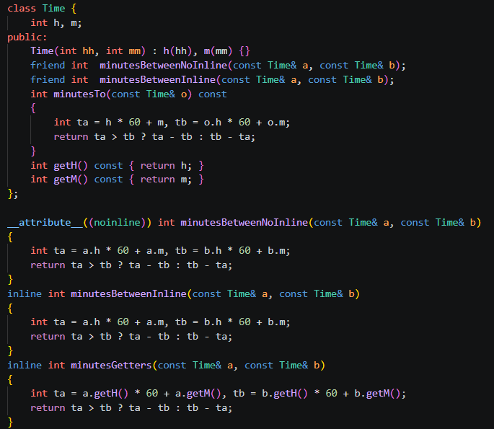
Version (10,000,000 calls) | -O0 time (ms) | -O2 time (ms)
Friend, noinline | 59.4 | 14.4
Friend, inline keyword | 57.6 | 12.6
Member function | 72.9 | 11.4
Public getters | 101.3 | 12.4

Explanation. At -O0 the inline keyword makes no difference (59.4 vs 57.6 ms is just noise), because the compiler does not inline when optimisation is off. The getter version is slowest (101 ms) because each of the four getter calls per comparison is a real function call. At -O2 the picture changes: the call overhead disappears, and the noinline version is about 13% slower than the inline one (14.4 vs 12.6 ms). The member and getter versions are inlined automatically and are as fast as the friend inline version (11 to 12 ms). So at -O2 the keyword matters less than the optimiser, and the difference for this tiny function is only around 2 ms per 10 million calls. The timings come from my machine; the exact milliseconds on another computer will be different, but the pattern should be the same.

6.5 Deployment Decision
I would keep the friend functions, defined inline in the header. Reasons: the operations are symmetric, so a normal function call reads naturally; h and m stay private and no getters are needed (getters would let every part of the program read the raw hours and minutes); and at -O2 they are as fast as the member and getter versions. The cost of this choice is that the friends are tightly connected to the internals of Time: if the representation changes, these two functions must be changed too, which is acceptable because there are only two and they are next to the class. If the project later wanted more operations on Time, I would reconsider and add a small public interface.

6.6 Alternative Concept and Complexity Analysis
// member version
int minutesTo(const Time& o) const { int ta = h*60+m, tb = o.h*60+o.m; return ta > tb ? ta-tb : tb-ta; }
bool isEarlier(const Time& o) const { return h*60+m < o.h*60+o.m; }

// getter version
int getH() const { return h; } int getM() const { return m; }
// then a free function minutesBetween(a,b) uses a.getH() * 60 + a.getM() ...

 | Friend | Member | Public getters
Time per call | O(1) | O(1) | O(1)
Measured -O0 / -O2 (ms per 10M) | 57.6 / 12.6 | 72.9 / 11.4 | 101.3 / 12.4
Space | O(1) | O(1) | O(1)
Encapsulation | Private data stays private; only two named functions have access | Best: only class members have access | Weakest: everybody can read h and m
Call style | minutesBetween(a, b) | a.minutesTo(b) | free function using getters

After inlining (-O2) all three have almost the same speed, so the choice should be based on encapsulation and readability, not speed.

Q7 – Diagnose, Redesign and Validate (13 Marks)
Selected program: Q4 – SavingsAccount mini-statement (shifting array). Folder: Q7 Files: bench_history.cpp, sizes.cpp

A. Diagnose the Limitation (2 Marks)
When the 11th transaction arrives, my record() moves every stored transaction one place left. For capacity k that is k − 1 copies of a 24-byte record for every single deposit or withdrawal, so the cost grows with k. The bank's next requirement (50 transactions) makes this worse. I measured 1,000,000 transactions with the same program for different capacities:
Capacity k | Shift, -O0 (ms) | Shift, -O2 (ms) | Time per transaction at -O0
10 | 21.6 | 11.7 | ≈ 22 ns
50 | 92.2 | 14.0 | ≈ 92 ns
500 | 691.9 | 69.9 | ≈ 0.69 µs
5000 | 7134.6 | 2343.8 | ≈ 7.1 µs

The time per transaction grows almost in proportion to k (at -O0, from k = 50 upward, every 10 times more capacity gives about 7.5 to 10 times more time). The cause is a property of the design, not of the compiler: the position of a transaction in the array depends on its age, so removing the oldest one forces every other one to move. At -O2 the small cases look better, because the compiler turns the loop into a fast block copy, but the O(k) growth is still clearly visible from k = 500.

B. Design Objective (2 Marks)
The redesigned class must satisfy all of these, measured with the same program on the same machine:
- Recording a transaction must take constant time: for k = 5000 the time for 1,000,000 transactions must be within 2 times the time for k = 10 (at both -O0 and -O2).
- At k = 50 (the bank's new requirement) it must be at least 5 times faster than the shifting version.
- The mini statement must be identical to the original (checked with diff).
- Extra memory per account must not be more than one int.

C. Design of the Revised Solution (4 Marks)
Change: keep the same fixed array but stop moving elements. Store the index start of the oldest transaction. A new transaction goes to slot (start + count) % MAX while the array is not full; when it is full, the new transaction overwrites the oldest slot and start moves forward by one (wrapping to 0 at the end). The statement is printed by visiting (start + i) % MAX for i = 0 … count − 1. The public interface (deposit, withdraw, miniStatement) is unchanged, so no calling code changes.
C++ features used: private data members, private member function record(), modulo arithmetic, and the same class specification as before (this is a design change inside the class, no library container).
Extra memory: one int (start). I checked with sizeof: the object is 264 bytes in both versions for k = 10 and 1224 bytes in both versions for k = 50, because the new int fits into padding bytes that already existed.
Trade-offs: the array is no longer in chronological order in memory, so the code that reads it must map the index (a bit harder to read and to debug); a modulo or compare is done on each access; and any code that wants a plain ordered array (for example to pass to another function) would have to make a copy first.
Class diagram
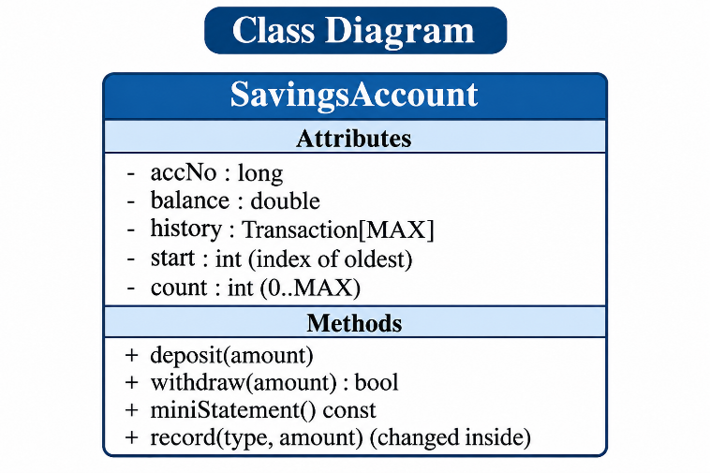
Pseudocode of record()
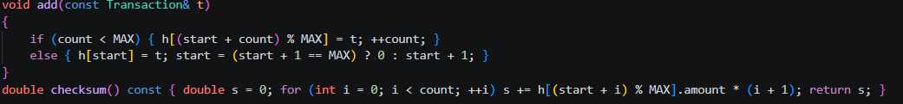

D. Predict Before Implementing (1 Mark)
The shifting version does about k − 1 copies per transaction and the circular version does one write. So I predict that the circular version's time will stay almost the same for every capacity (within about 1.5 times), while the shifting time grows roughly in proportion to k. The speed-up of circular over shift should therefore be small for k = 10 (about 3 to 8 times), around 10 to 30 times for k = 50, and more than 100 times for k = 500 and k = 5000. The measure is the time for 1,000,000 transactions.

E. Implement and Validate (2 Marks)
Both versions run the same test (1,000,000 transactions, best of 5 runs, the same data). A checksum of the final statement was equal for shift, circular and deque in every run, and the full 12-transaction statement of Q4 was identical (diff printed no difference).
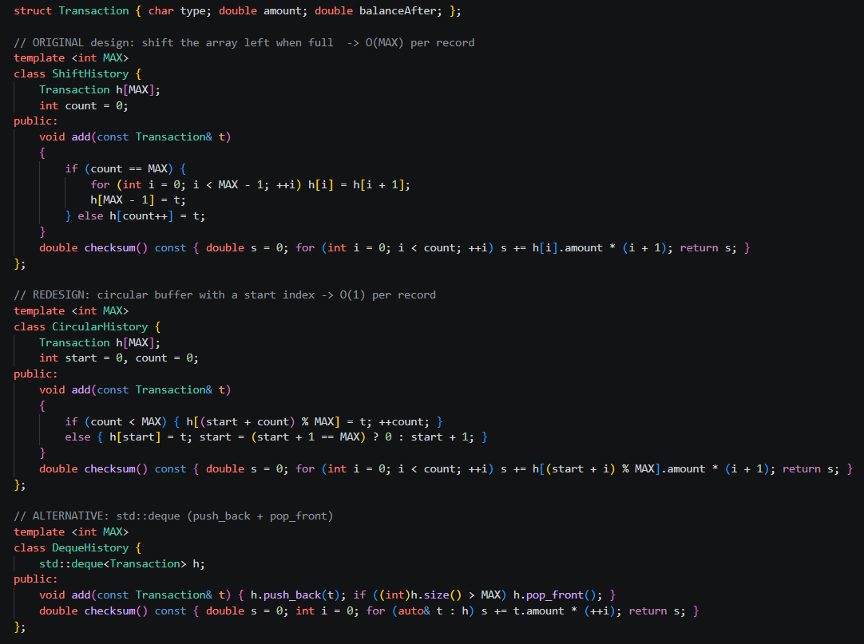
Original (shift) → Redesigned (circular), with deque for comparison
k | Shift O0 (ms) | Circular O0 (ms) | Shift O2 (ms) | Circular O2 (ms) | Deque O2 (ms) | Speed-up O0 / O2
10 | 21.6 | 3.87 | 11.7 | 1.57 | 10.4 | 5.6× / 7.5×
50 | 92.2 | 3.47 | 14.0 | 0.93 | 6.6 | 26.6× / 15.1×
500 | 691.9 | 3.22 | 69.9 | 1.05 | 7.8 | 215× / 66×
5000 | 7134.6 | 3.73 | 2343.8 | 1.11 | 8.0 | 1913× / 2120×

Result against my prediction: the circular time stayed flat (3.2 to 3.9 ms at -O0 and 0.9 to 1.6 ms at -O2 across all capacities), as predicted. The speed-ups were also in the predicted order for k = 10, 50 and 5000. The one place where I was off is k = 500 at -O2: I expected more than 100 times but got 66 times, probably because at -O2 the compiler turns the shifting loop into fast block copies, which are cheap while the data is small; the shifting cost then jumps at k = 5000, where the 120 KB of records no longer fits comfortably in the fast cache.

F. Defend the Final Design (2 Marks)
Was the objective achieved? Yes, all four parts. (1) Circular time for k = 5000 is 3.73 ms at -O0 versus 3.87 ms for k = 10, and 1.11 ms versus 1.57 ms at -O2, so it is well inside the 2× limit. (2) At k = 50 it is 26.6 times faster at -O0 and 15.1 times at -O2, above the 5× target. (3) The statement is identical. (4) Extra memory is one int, which cost 0 extra bytes because of padding.
New costs: harder-to-read index logic, a possible off-by-one bug in the wrap-around, and the data in memory is not in time order.
Where the original may still be preferable: for the original k = 10 the shifting version takes only about 22 ns (-O0) or 12 ns (-O2) per transaction, which is far too small to notice at an ATM. Its code is the simplest to read and test, and the array is always in order, so a statement can be printed or passed on directly. So if the capacity was never going to change, the original is good enough. The redesign is worth it because the bank's requirement is already changing (10 → 50) and may change again, and because the cost no longer depends on that decision.
About std::deque: it also gives O(1) per transaction and needs no index arithmetic, but in my measurement it was about 6 to 8 times slower than the circular buffer (6.6 to 10.4 ms at -O2 against 0.9 to 1.6 ms), because it allocates memory in blocks on the heap and has an extra level of indirection. It would be the better choice if the number of stored transactions had to be changed at run time.

